Experiment:27 Date:18/08/2027
FRUIT AND COLOR USING BACKTRACKING

Aim
To write a Prolog program to find the color of a fruit using backtracking.

Algorithm
- Start the program.
- Define facts containing fruits and their colors.
- Create a rule to find the color of a fruit.
- Query a fruit or color.
- Use Prolog backtracking to find all matching results.

Program
fruit(apple, red).
fruit(banana, yellow).
fruit(orange, orange).
fruit(grapes, green).
fruit(mango, yellow).
fruit(guava, green).

find_color(Fruit, Color) :-
fruit(Fruit, Color).

OUTPUTS:

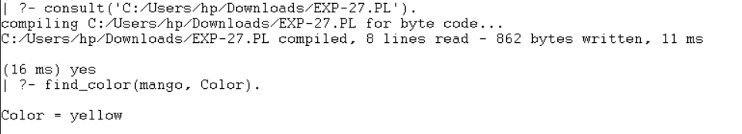

RESULTS:
Thus, the fruit-color program was successfully implemented using Prolog backtracking.

